**Analyzing the best location for a new restaurant**

*By Amine, for IBM Data Science Certificate Capstone*

**Introduction**

The restaurant industry is difficult to succeed in. Aside from the operational challenges, there are two external factors that are required to survive:

1) Regular foot traffic

2) An underserved population that they can address

Foot traffic may come from locals and tourists visiting other nearby venues, from the people that live in that neighborhood, or in some cases: a busy work center/industrial area

A well organized restaurateur will know their particular cuisine style, price range, and desired target customers. A target customer in this case can be defined as underserved if there’s a lack of other options that serve this restaurant’s style, price, and theme (ie, an italian restaurant in little Italy will have a hard time differentiating itself)

**Business Explanation**

The restaurant in mind for this study is a new chinese style, modeled after one of my favorite restaurants in Boston : Double Chin Cafe

This restaurant caters to a younger crowd, mostly in their 20’s and 30’s. Their menu serves fast, cheap, and delicious eats with an emphasis on regularly creating fun dishes.

Their late-night menu begs for them to be the last stop after a long night on the town. The target customer is groups looking for something to eat in between visiting art shows, concerts, bars, and other big social events

**Business Problem**

The issue here is, we don’t know where the restaurant should be located. The owners had success with their first restaurant in Chinatown, but the crowding of other places serving similar fare made it extremely difficult to stand out.

Aside from Chinatown, the owners don’t know where else to look. They need a neighborhood with a steady stream of customers visiting other nightlife options, with hopefully not too many other Chinese/Asian fusion restaurants in the area.

Can we use publicly available data to source potential new locations for their restaurant?

**Data**

To attempt a solution at this problem, we’ll be using the Foursquare API to fetch venue information and analyze different neighborhoods.

To fulfill the requirements of the business problem stated, we’ll specifically be looking for two types of information:

- Data on the neighborhoods in general, specifically:

- The categories for each venue in each Brooklyn neighborhood

- The popularity for each of the target venues, determined by:

- The total number of tips

- The number of likes

- Data on venues that might compete with ours, specifically:

- The relative frequency of all restaurants

- The relative frequency of specifically Chinese/Asian Restaurants

**Data (fetching popular venues in a neighborhood)**

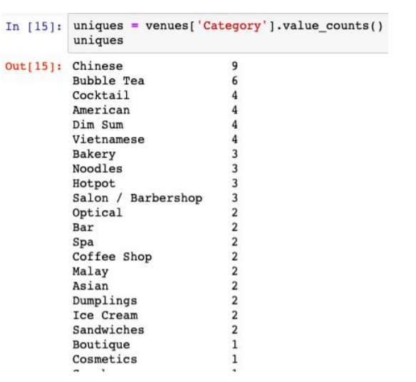

**Data (fetching number of tips)**

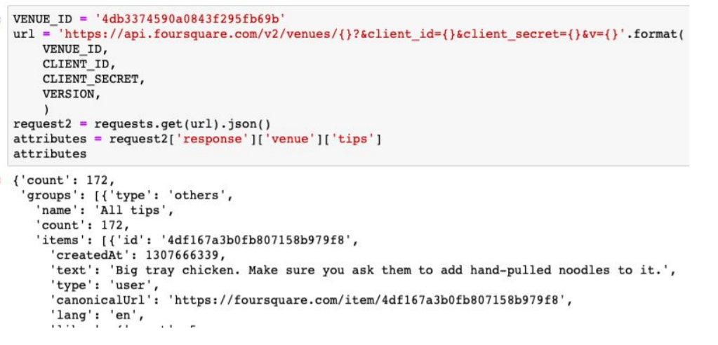

**Methodology**

After fetching data for all venues and neighborhoods in Brooklyn, I filtered out the specific venues I was interested in (Restaurants and Nightlife venues). I then picked venues from this list that had a high number of likes and tips (showing high popularity). This list was used to narrow down the neighborhood list to just 19 entries

I took the filtered list, and searched for venues again, this time with a little wider search radius and a higher limit on the # of venues

I took the information from this list of “hot” neighborhoods and pulled together a relative frequency of nightlife venues, restaurants, and then Chinese Restaurants

